OUM

Technical Design Specification

Host to Host – AP Payment Outbound

MAY BANK Malaysia

 

|  |  |  |
| --- | --- | --- |
| Author | : | Benin Tharmalingam |
| Creation Date | : | September 17, 2021 |
| Last Updated | : |  |
| Document Ref | : |  |
| Version | : | Draft |

1. **Title, Subject, Last Updated Date, Reference Number**, **and** **Version** are marked by a Word Bookmark so that they can be easily reproduced in the header and footer of documents. When you change any of these values, be careful not to accidentally delete the bookmark. **You can make bookmarks visible by selecting Tools->Options…View and checking the Bookmarks option in the Show region.**

**Approvals:**

|  |  |
| --- | --- |
|  |  |
|  |  |
|  |  |

1. To add additional approval lines, press [Tab] from the last cell in the table above.
2. You can delete any elements of this cover page that you do not need for your document.

# **Document Control**

## **1.1 Change Record**

| Date | Author | Version | Change Reference |
| --- | --- | --- | --- |
| 17-09-2021 | Benin Tharmalingam | Draft |  |
|  |  |  |  |
|  |  |  |  |
|  |  |  |  |

## **1.2 Reviewers**

| Name | Position |
| --- | --- |
|  |  |
|  |  |
|  |  |
|  |  |
|  |  |

## **1.3 Distribution**

| Copy No. | Name | Location |
| --- | --- | --- |
|  |  |  |
|  | <Distribution List> | <Location> |
|  |  |  |
|  |  |  |
|  |  |  |

**Note To Holders:**

If you receive an electronic copy of this document and print it out, please write your name on the equivalent of the cover page, for document control purposes.

If you receive a hard copy of this document, please write your name on the front cover, for document control purposes.

Table of Contents

**1.** **Document Control** 2

**1.1** **Change Record** 2

**1.2** **Reviewers** 2

**1.3** **Distribution** 2

**2.** **Overview** 4

**2.1** **Business Needs** 4

**2.2** **Source and Destination System** 4

**2.3** **Audience** 4

**2.4** **Related Documents** 4

**2.5** **Glossary** 4

**3.** **BanK Interface for Outbound payment** 5

**3.1** **Interface Definition** 5

**3.2** **Outbound Payment Mapping Sheet** 5

**3.3** **Interface Mapping Steps** 5

**3.4** **Payment File Structure DOM** 6

**3.5** **Payment File Structure INTL** 6

**4.** **Transformation** 7

**5.** **Error and Exception handling** 8

**6.** **E - Text TEMPLATE** 9

**6.1** **Interface Sample Payment output files** 9

**7.** **Assumptions** 10

**8.** **Open and Closed Issues** 11

**8.1** **Open Issues** 11

**8.2** **Closed Issues** 11

# 

# **Overview**

The purpose of this document is to provide ASCOTT with an insight of a Technical design and implementation details, for an Outward Payment interface with MAY Bank, using E-Text template based on the mapping specification.

## **2.1 Business Needs**

1. This section describes the mapping between this package or use case and the business requirements that have been identified in RD.001 Business and System Objectives. Only list objectives that are impacted by this use case or Use Case package.

Ascott is using Payment Module to integrate with MAY Bank. Currently Payment module is designed to work with bank in Host to Host mechanism.

In host to host, AP Payment is created in SaaS, User validates and generates electronic payment files, and Payment file will be encrypted and transmitted to bank securely.

## **2.2 Source and Destination System**

Source 🡪 ASCOTT SaaS Application Instance

Target 🡪 MAY Bank Server

## **2.3 Audience**

This document is primarily aimed at:

* The Ascott and Oracle Architecture Teams
* Developers who will develop the Bank interface for MAY Bank Outward Payment

## **2.4 Related Documents**

Mapping Excel Sheet created based out of the specification document

## **2.5 Glossary**

| **Abbreviation** | **Definition** |
| --- | --- |
| SaaS | Software as a Service |
| RTF | Rich Text Format |
| e-Text | Electronic Text |

# **BanK Interface for Outbound payment**

## **3.1 Interface Definition**

| Property | Value |
| --- | --- |
| Describe this interface | The interface will generate a text output which will make the MAY Bank to recognize the payment |
| Input to the Interface | H2H once payment made, payment file will get transmitted to Bank. |
| What does this Payment Interface do? | * This payment interface will convert the source file of payment into e-Text format * The data will be delimited according to the MAY Bank mapping specification * It will give the text file output * This Text file output is used to generate the payment remittance to the Bank |
| Identifier | MY_FT_BULK_PAYMENT_DOM  MY_FT_BULK_PAYMENT_INTL |
| Where is this file located? | Shared Folders/ Custom/Financials/Payments |

## **3.2 Outbound Payment Mapping Sheet**



## **3.3 Interface Mapping Steps**

|  |  |
| --- | --- |
| 1 | This mapping sheet will provide the tags of corresponding columns for Bulk Payment that are to be mapped in e-Text template. |
| 2 | The Tags which are mentioned in the mapping sheet are from the source file of particular payment |
| 3 | Each Segment is considered as a new record. |
| 4 | The format is grouped for each Outbound payment |

## **3.4 Payment File Structure DOM**

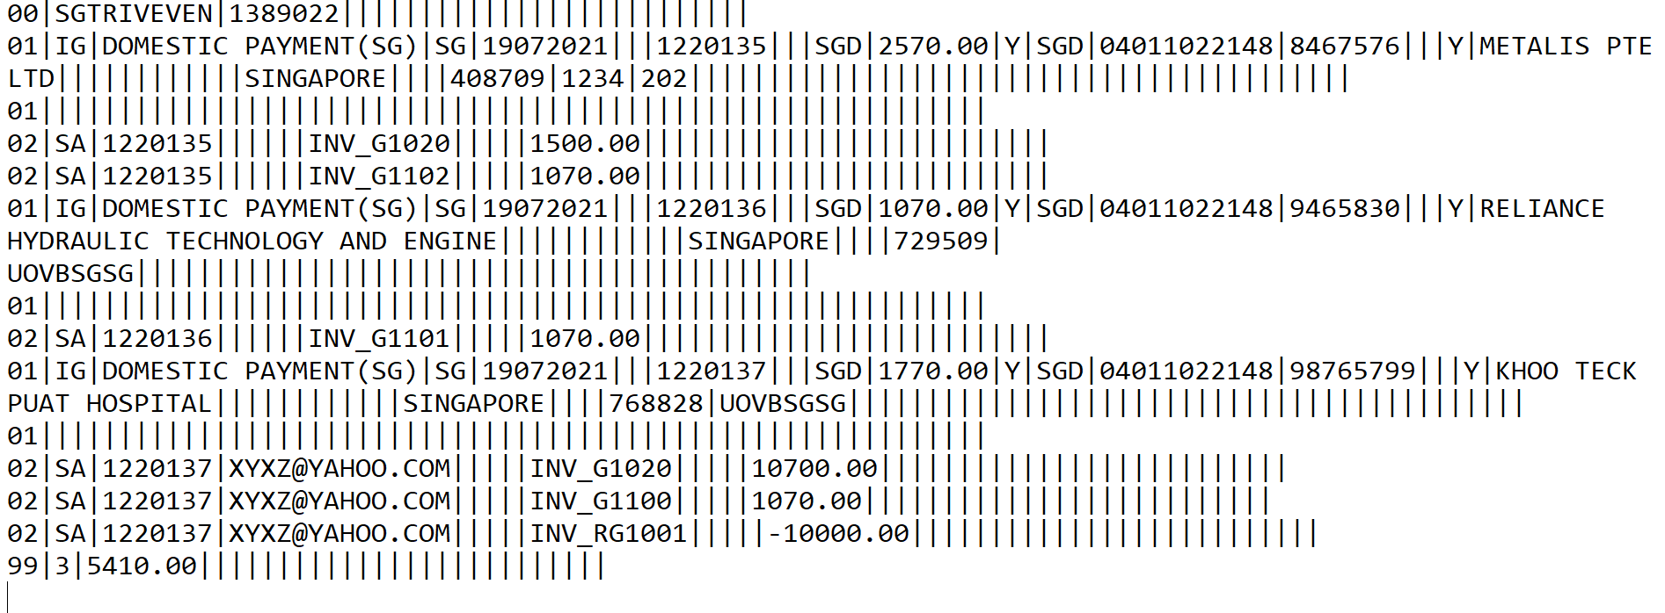

## **3.5 Payment File Structure INTL**

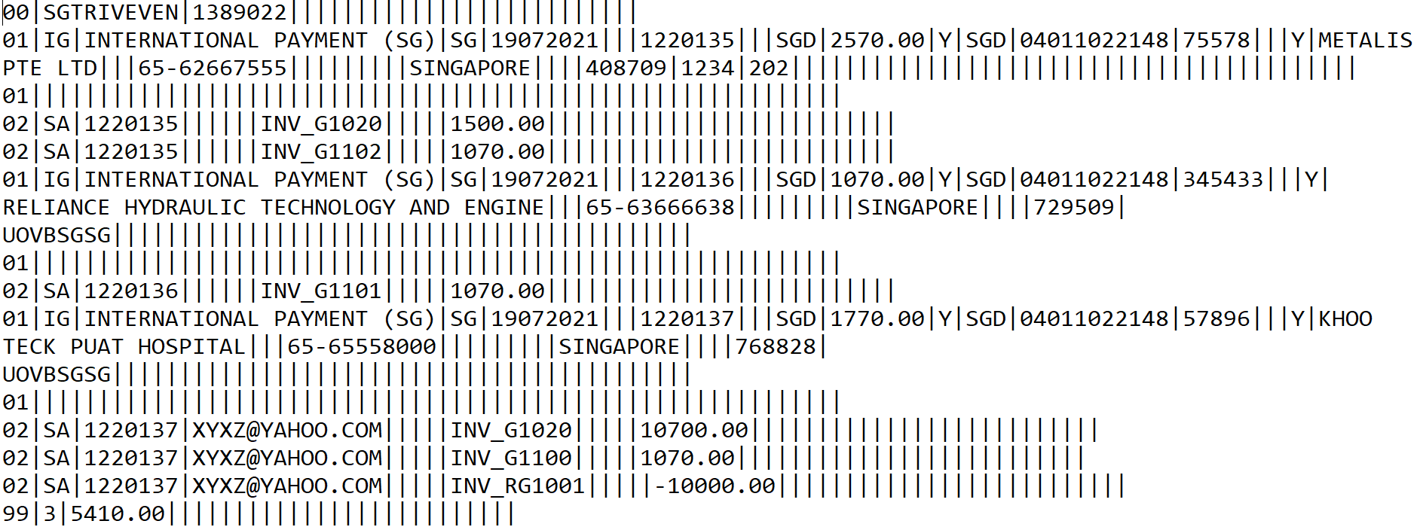

# **Transformation**

**Transformation Rule**

Below are the formatting rules that has to be followed for MAY Bank:

* The template type for MAY Bank Outward Payment is DELIMITER_BASED Template
* The Case conversion type must be in UPPER case
* The new record character set must be in Carriage Return type
* ‘|’ is being used as a Delimiter Character
* The MAY Bank Outward Payment e-Text format is grouped by Payment wise order.
* Output character set must be in ISO-8859-1 format and is in .txt format
* Given below the sample template format setup , with the above mentioned points

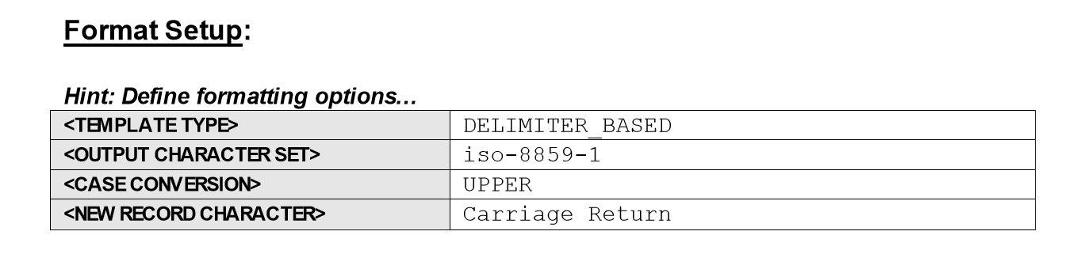

# **Error and Exception handling**

Any Transmission Failure indicated in below schedule process log file

1. Payment File Register
2. Format Payment Files
3. Transmit Payment File

Based on the log file, issue needs to be resolved and reprocess the payment file.

# **E - Text TEMPLATE**

Attached is the E-Text Payment outbound templates , desgined as per the mapping specification

 

## **6.1 Interface Sample Payment output files**

 

# **Assumptions**

There are the following assumptions we have considered while developing the Technical Design

1. No email notification will be provided to the IT team if the process is successful.
2. ASCOTT will retain the source files for a period of 12 months in archive directory as part of retention and any file over this period will be purged.

# **Open and Closed Issues**

1. Add open issues that you identify while writing or reviewing this document to the open issues section. As you resolve issues, move them to the closed issues section and keep the issue ID the same. Include an explanation of the resolution.  
     
   When this work product is complete, any open issues should be transferred to the project- or process-level Issue Log (Manage focus area) and managed using a project level Issue Form (Manage focus area). In addition, the open items should remain in the open issues section of this work product, but flagged in the resolution column as being transferred.

## **8.1 Open Issues**

| ID | Issue | Resolution | Responsibility | Target Date | Impact Date |
| --- | --- | --- | --- | --- | --- |
|  |  |  |  |  |  |
|  |  |  |  |  |  |
|  |  |  |  |  |  |
|  |  |  |  |  |  |

## **8.2 Closed Issues**

| ID | Issue | Resolution | Responsibility | Target Date | Impact Date |
| --- | --- | --- | --- | --- | --- |
|  |  |  |  |  |  |
|  |  |  |  |  |  |
|  |  |  |  |  |  |
|  |  |  |  |  |  |